
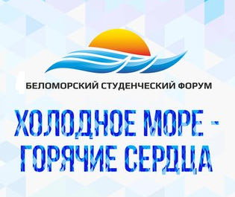
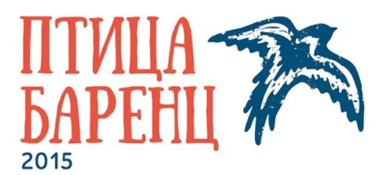

REGISTRATION FORM
III International Belomorskiy Students Forum November 23-24, 2015
NArFU, Arkhangelsk

I. PERSONAL DATA
Surname
First name |  | Middle name
Date of birth
Organization
Position/status
Gender | Male Female | Citizenship
Country
Phone |  | Mob. phone
Е-mail

II. TRAVEL DETAILS
Arrival to Arkhangelsk  (date, time, flight number) |  | Departure from Arkhangelsk (date, time, flight number)

III. ACCOMMODATION IN ARKHANGELSK (double-rooms)| *
I would like to book a room in Arkhangelsk |  | Yes No
Number of nights | 3 nights (Nov. 22 – Nov. 25)  Yes No
*Hotel costs are covered by the organizers

IV. VISA INFORMATION
I need an invitation for Russian visa | Yes No

V. CONFERENCE
I’d like to make a presentation | Yes No
Topics (please, underline the most preferable) | - Plenary session “Youth Cooperation in the Barents Region  - Workshops:  - International projects of the Youth  - Research projects of young scientists  - Students self-governance

VI. EDUCATIONAL EXHIBITION
We’d like to present our Organization on the Educational Education | Yes No

VII. DIETARY RESTRICTIONS (if any)
Please, specify
Please, forward this Registration Form until October 15, 2015 at o.aldaeva@narfu.ru
(NArFU International Office, contact person – Olga Aldaeva)

